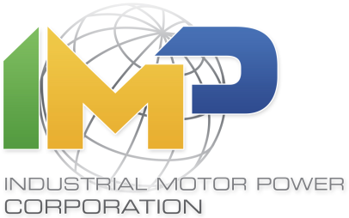
IMP NEWS - FOR IMMEDIATE RELEASE
Contact: Alexandra Nadjarian, Marketing Coordinator
Phone: (323) 268-3380
Email: marketing@impcorporation.com

Headline:
IMP Announces Addition of New Divisions with Launch of New Website.

Summary:
Industrial Motor Power launches new web site to improve user experience and accommodate the addition of recently added divisions.

Los Angeles, California, October 27, 2014 - A global supplier of power equipment, Industrial Motor Power Corporation, announced the integration of three new divisions into its company portfolio. The announcement was made concurrently with the launch of its next generation website (www.impcorporation.com).

The new divisions, IMP Latin America, Rental Power Solutions, and Custom Power Solutions streamline the organization's capability to provide equipment to the global market. The units include two former IMP subsidiaries, as well a new custom solutions division.

IMP Latin America, formerly International Power Traders, utilizes its Miami, Florida offices to focus on the company's core business in the Latin American market. (www.implatinamerica.com)

Rental Power Solutions has been serving the domestic and international markets for several years. Now IMP’s fully operational rental division with offices in Miami, Florida, the company fulfills and bids on short and long term rental projects. (www.imprps.com)

Custom Power Solutions is a newly created division operating out of IMP's corporate offices in Los Angeles, California. CPS manages IMP’s new Global Partnership with SDMO. It offers a full suite of both standard packages and custom engineered solutions direct from SDMO’s factory. (www.impcps.com)

IMP’s new website, developed in collaboration with the company's customers, provides a platform for direct interaction with IMP and its divisions. The site also incorporates a custom user interface for a simpler user experience, offers dynamic equipment search capabilities, and is accessible from any portable device or smart phone. Scalable, the site will continue to provide the industry's leading technological applications to meet customer specific needs.

IMP is one of the largest independent suppliers of new, surplus, and used power equipment in the world. The company specializes in providing diesel, natural gas, and turbine power equipment worldwide. Operating in the power generation market for more than 30 years IMP is both an inventory owner and supply chain manager of generators, engines, and accessories.

Please visit www.impcorporation.com/news for more information, news and related data about IMP. If you have further questions, please direct inquiries via email to the public relations department at marketing@impcorporation.com, or contact us directly by telephone at (323) 268-3380.

